Jo Ellen Chatham Ph. D.

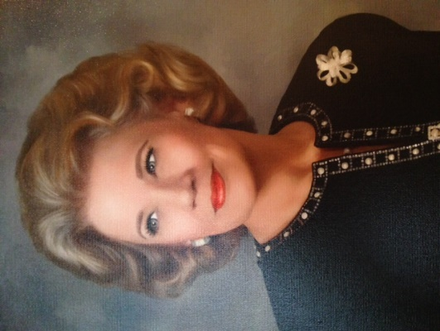
Dr. Jo Ellen Chatham is Director of the Center for Civics Education at Concordia University Irvine. She has developed a model community citizenship project, USA250-OC, whose mission is to increase the levels of civility and civic literacy in Orange County through the commemoration and celebration of the 25^{0th} anniversary of the Declaration of Independence and the birth of the United States. USA250-OC is a non-profit, non-partisan and non-sectarian endeavor to engage the widest possible members of the Orange County community.
She is a past member of the Board of Directors of the Public Media Group of Southern California which governs the operations of KOCE and KCET public television stations. For ten years she was the Chairman of the Board of Trustees of KOCE (aka PBS So CaL). In 2015, she retired as Director of Public Affairs for the Southern Region of Southern California Edison (SCE) where her team of Region Managers was responsible for managing the relationships between SCE, the County of Orange and more than fifty cities in Los Angeles and Orange Counties.
Jo Ellen served for six years as the Lay-Vice Chair of the Association of Public Television Stations (APTS) and continues to serve as a member of the Executive Committee of the Board of Directors of the Pacific Symphony and as a member of the Boards of Directors of the Orange County Forum, the World Affairs Council of Orange County, Orange County Music and Dance, and the Irvine Music Festival.
For nearly 15 years, Jo Ellen was an Associate Professor of Political Science at West Los Angeles College where she also served as an administrator and officer in the Faculty Senate. Prior to joining SCE, Jo Ellen was president of Eagle Forum of California, a non-profit public policy organization. She was appointed by Governor Pete Wilson to the Board of Governors of the California State Bar Association and the Narcotic Addict Evaluation Authority. She was a member of the Board of the Henry Salvatori Forum at the University of Southern California and served on the Orange County Commission on the Status of Women and on boards of numerous organizations, including the Orange County Business Council (Vice Chairman), the World Affairs Council of Orange County (Chairman), the Orange County Forum (President), Red Cross of Orange County (Secretary), the Orange County High School of the Arts Foundation Board, Leadership Council of the Center for the Study of Democracy at the University of California Irvine, the Board of Visitors of the Chapman University School of Law and the Orange County Taxpayers Association.
Jo Ellen was the Republican nominee in the 69th State Assembly District in 1992 and alternate delegate to the 1996 and 2004 Republican National Conventions. For 15 years she served as the First Vice-Chairman of the Republican Party of Orange County and is First Vice Chairman Emeritus. She has chaired the Education Committee, Speakers' Bureau and the Political Education Committee for the California Republican Party, is currently a member of the California Republican Central Committee and served for many years as vice chair of its Resolutions Committee.
In 1987, Jo Ellen authored “A More Perfect Union: The Constitutional Convention of 1787” which received official recognition by the United State Commission on the Bicentennial of the Constitution. She is listed in the Eighth Edition of World's Who's Who of Women and was named "Woman of the Year" by the California Legislature in 1987. In 1993 she was awarded "Woman of the Year" by the Women's Coalition. In 2011 Jo Ellen received the "Visionary Award" conferred by the Coast Community College District and was awarded "The Golden Orange" award by the Orange County World Affairs Council. In 2013 she received the “David J. Brugger Award for Grassroots Advocacy”’ from APTS. In 2015 she was a recipient of the Ellis Island Medal of Honor and received the 2016 Distinguished Service Award from the Black Chamber of Commerce of Orange County.
Among Jo Ellen’s most prized accomplishments are proposing and bringing to fruition a documentary history of Iranian Americans which was aired nationally on PBs and Peter Boyer’s “Ellis Island: The Dream of America” performed by the Pacific Symphony, which also aired nationally on PBS. She also hosted an 18-part lecture series at the Richard Nixon Presidential Library and Museum which consisted of lectures on the Declaration of Independence, the Constitution and the Bill of Rights. She was also one of three co-hosts of the 17-part YouTube series “Becoming America: The Constitutional Convention of 1787.””
Jo Ellen received her B.A. and M.A. in Political Science from California State University at Northridge and a second M.A. and Ph.D. in Political Science from the University of Southern California. Her doctoral dissertation is entitled “Constitutional Interpretation: Views of the Early Congresses Concerning Judicial Review and Original Meaning.” She also studied Consumer Economics in the UCLA graduate school.
For two years Jo Ellen was a panelist on NBC's Emmy Award-winning public policy program "Free 4 All" and a frequent guest in television and radio, including regular appearances on "CNN and Company" and guest commentator on "The Tom Snyder Show," "The Today Show," CBS's "News Makers", "Live in L.A.," “The Michael Reagan Show,” “The Bill Maher Show” and many others. She was a political columnist for the Daily Pilot and has organized and taught seminars in effective political action and media relations. She is a co-founder of the Alpha Political Campaign School and authored The Political Campaign Manual and The Citizen Action Manual.

